UID LAB EXPERIMENT 10
Create a data visualization (e.g., pie charts, bar graphs) for an inventory management system using javascript.
SAILOO S
230701277
Aim:
To create data visualizations such as pie charts and bar graphs for an inventory management system using JavaScript and Chart.js library.

Software/Tools Required:
- HTML5
- JavaScript
- Chart.js (via CDN)
- Any text editor (VS Code, Notepad++)
- Web browser (Chrome, Firefox, Edge)

Procedure:
Step 1: Set Up the HTML File
- Create a new file named index.html.
- This file will contain the structure of the web page and space (canvas elements) to display the charts.
- Also, we include the Chart.js library using a <script> tag that points to the CDN.
Explanation:
- <canvas> elements create blank areas where charts will be drawn.
- The external JavaScript (script.js) will fill these canvases dynamically with charts.
- Basic CSS styling is added to center everything nicely.
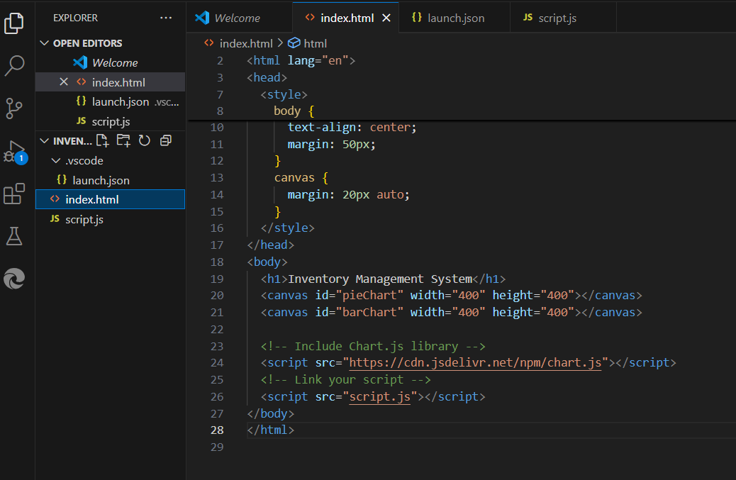

Step 2: Create the JavaScript File (script.js)
- Create a second file called script.js.
- This file contains the logic for setting up the data and drawing the charts.
Explanation:
- inventoryData object stores categories and their stock counts.
- Two different charts are created:
  - Pie Chart shows how the stock is divided among categories.
  - Bar Chart shows the exact number of items in each category.
- Animations (like bounce effects and hover enlargements) make the charts more interactive.
- Tooltips are customized to have dark backgrounds for better visibility.
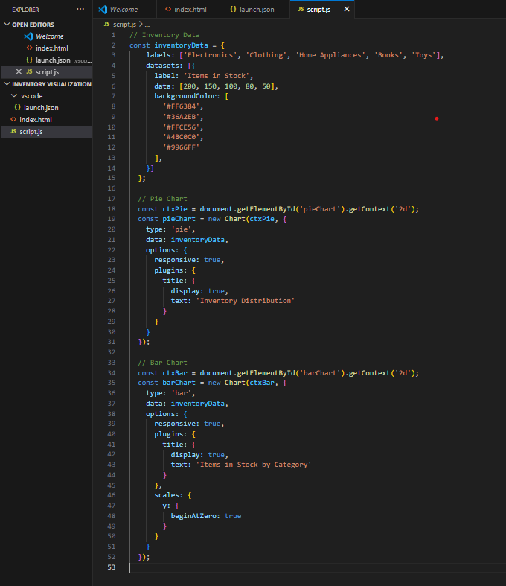

Step 3: Run the Project
- Save both files (index.html and script.js) in the same folder.
- Open index.html in any browser.
- You will see animated pie and bar charts representing the inventory stock.

Output:
Thus, we successfully created and visualized inventory data using pie charts and bar graphs with JavaScript and the Chart.js library, including customized animations and styling.
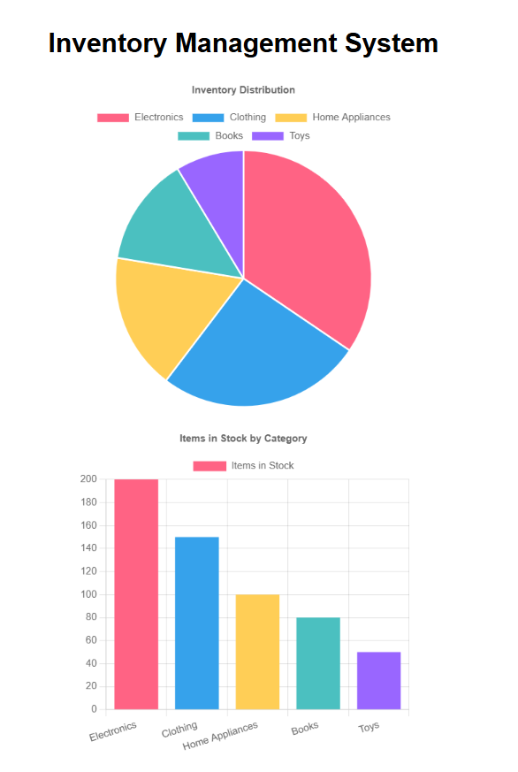
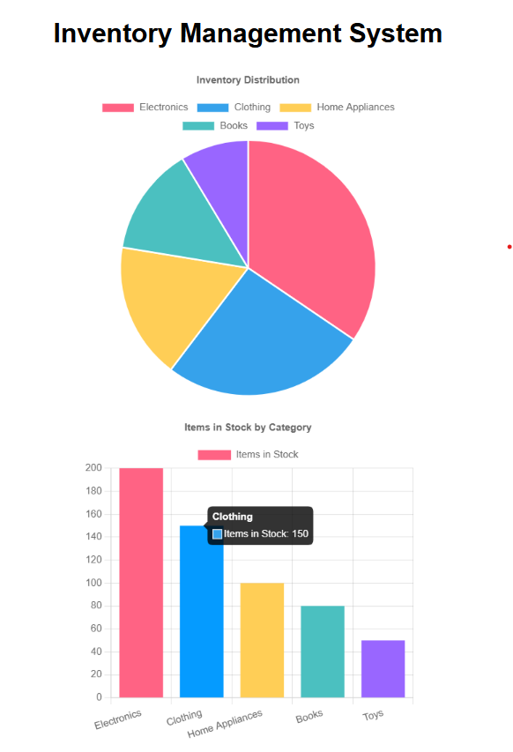
Conclusion:
In this experiment, we successfully designed an interactive data visualization system for an inventory management application using HTML, JavaScript, and the Chart.js library.
By setting up the HTML structure, connecting an external JavaScript file, and using Chart.js functionalities, we were able to generate both pie charts and bar graphs that clearly represented inventory data.
We also enhanced the user experience by adding animations, hover effects, and custom styling for better visual appeal and easier interpretation of data.
This project demonstrated the practical application of front-end web technologies for real-time data visualization, a skill that is widely used in dashboards, analytics platforms, and modern inventory systems.

